Heuristicas de Nielsen

**Consistency and Standards**

**Users should not have to wonder whether different words, situations, or actions mean the same thing. Follow platform and industry conventions.**

Because Windows 10 used Windows 7, 8, and 8.1 as a foundation, its design became very inconsistent.

Not every setting was ported from the Control Panel to the newer Settings app, which means that users might need to use a combination of both to achieve the configurations they desire. Sometimes the Settings app will redirect users to the Control Panel to access more specific settings. Other times, configurations are available on both programs. This makes it so there’s a mix of redundancy and inconsistency, which would be OK for a project during development, but a product being sold should not have these problems.

There are also a lot of different designs for the context menus in both the OS and the apps themselves (some of them native). A single consistent interface between all of them would be preferable.

Windows 10 has support for both standalone installers (usually downloaded from a website) and using the native Microsoft Store to install applications on the system. A lot of applications exist as both, which would seem good because it means the user has more options. But some of these applications might have different features depending on how they were installed. In the past, there were two different versions of Skype with different features available on the store vs the website.

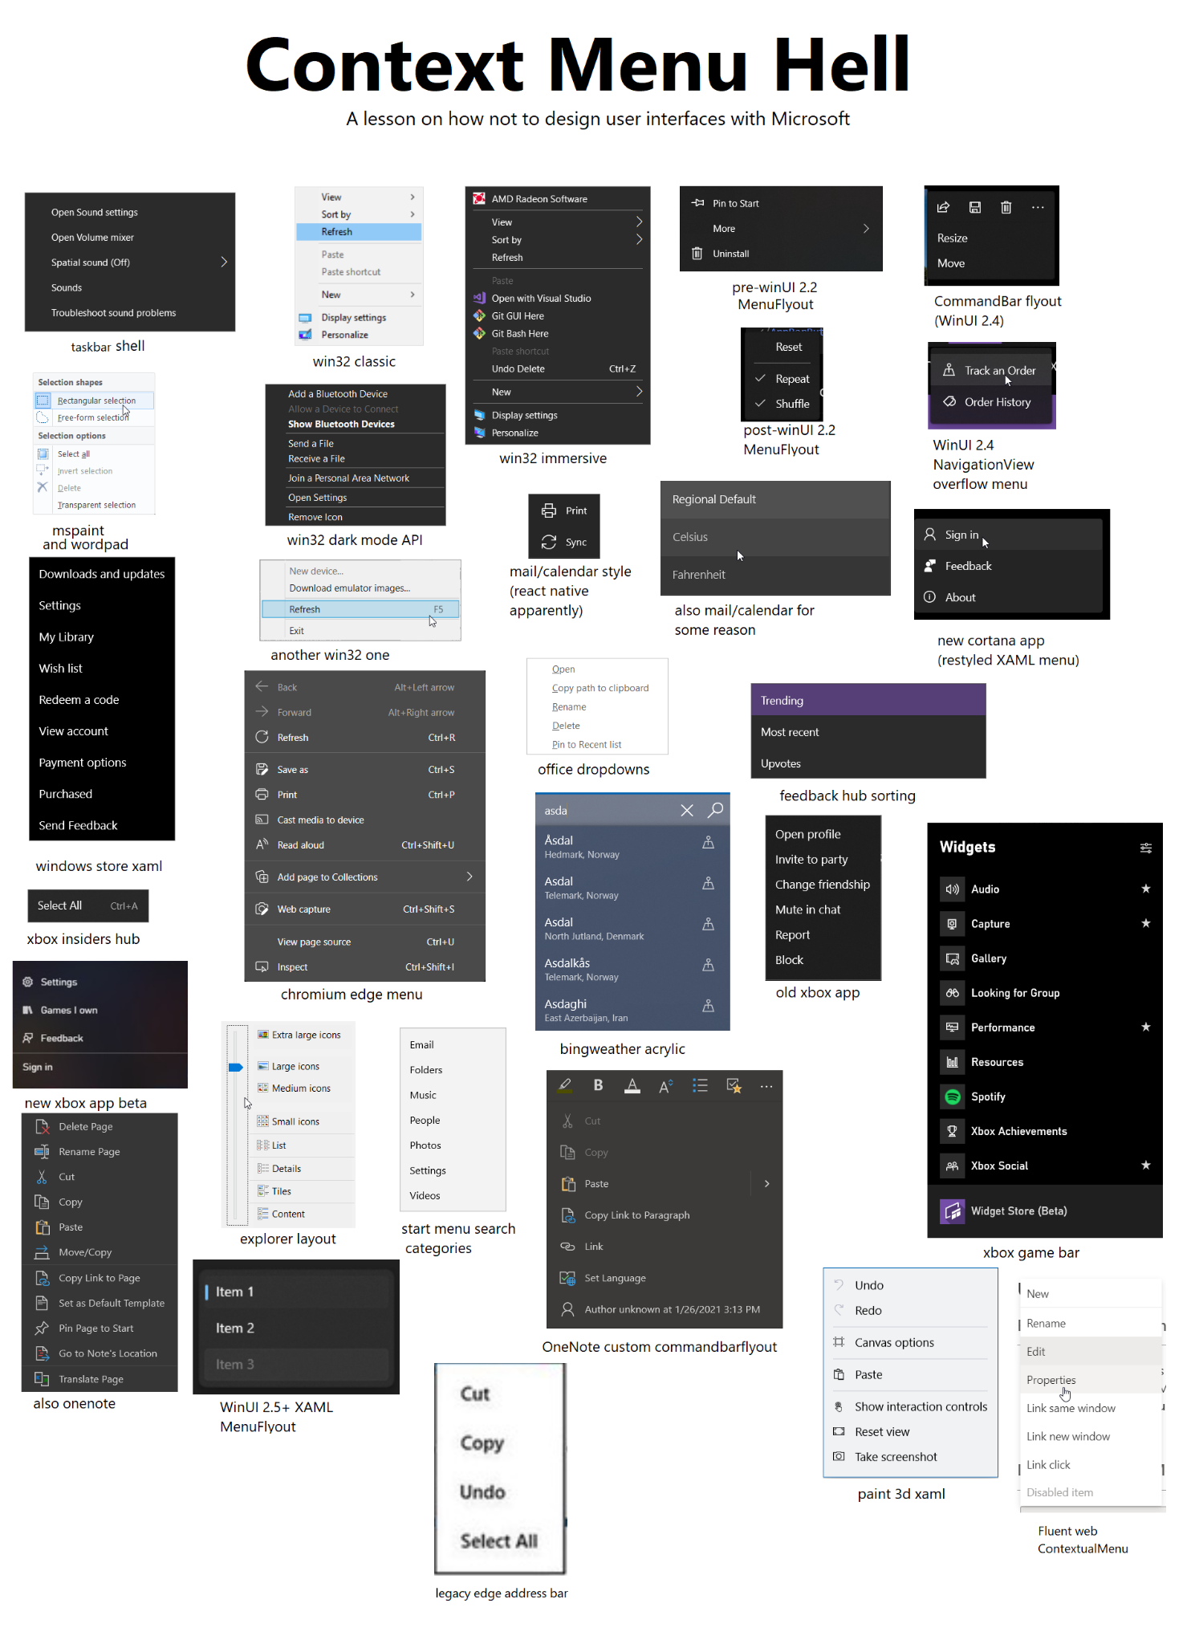Source: Reddit

**Help users recognize, diagnose, and recover from errors**

**Error messages should be expressed in plain language (no error codes), precisely indicate the problem, and constructively suggest a solution.**

Typically, when the traditional blue screen of death error appears, it does not tell the user in simple words what went wrong. The user must figure out by himself what happened.

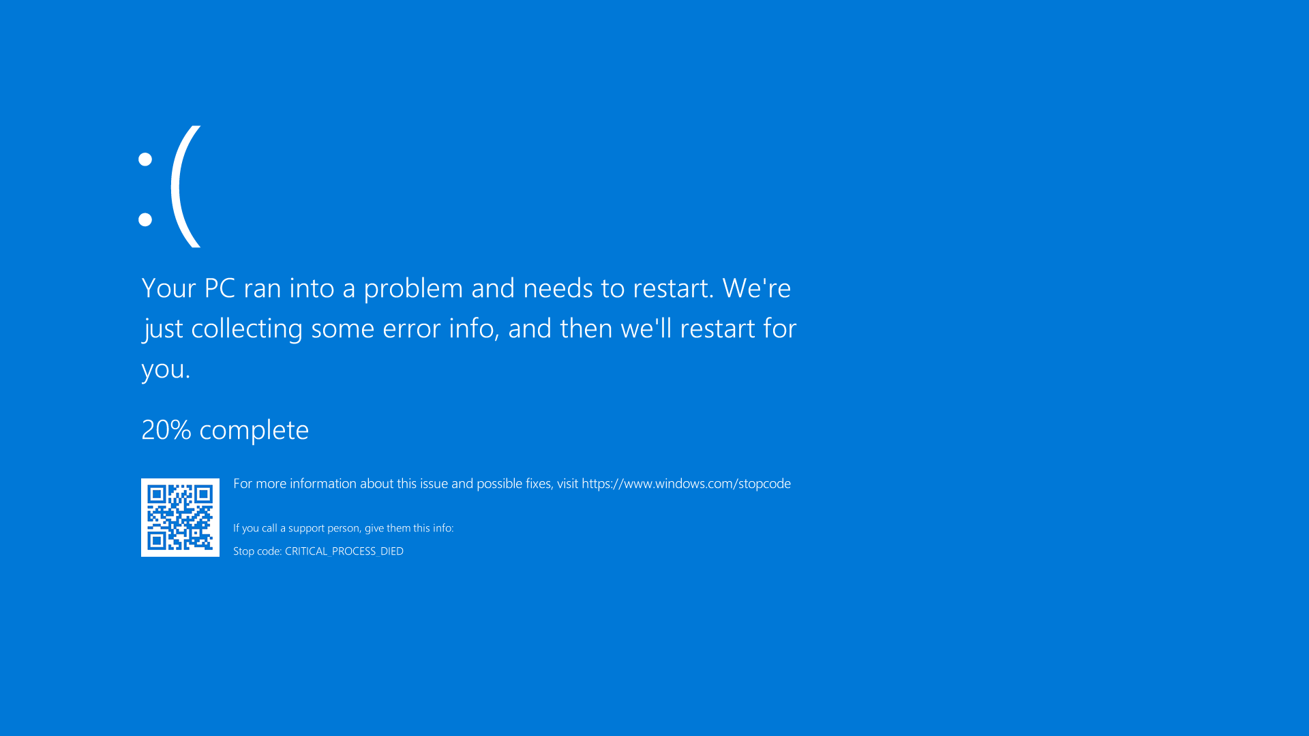

Additionally, this error is not visible for much time and may disappear within seconds without the user fully recognizing what went down.

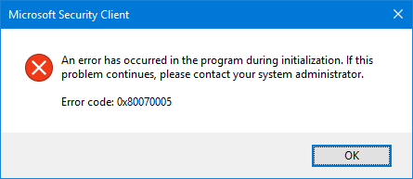

Error codes or “technical jargon“ being used to specify the error type.

**Visibility of system status**

**The design should always keep users informed about what is going on, through appropriate feedback within a reasonable amount of time.**

Some Windows 10 updates may take a long time to install without providing users with a clear progress indicator, leading to confusion and frustration. Some updates may have a proportional progress according to actual time spent and progress bar/percentage, but some upgrades are often at 0% for a very long amount of time and then skip to 100%. The user is, therefore, not appropriately informed about the status.

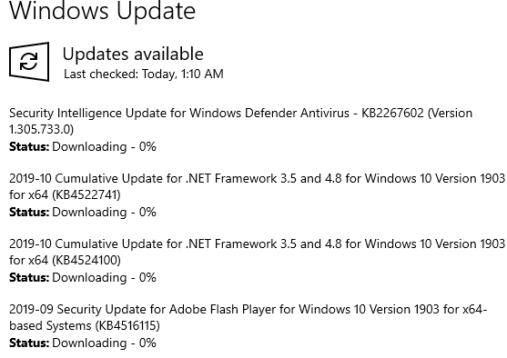

After opening Cortana (which can happen by accident by pressing Win+C) the process of closing it is not trivial. After pressing the X button it may look like it’s closed but by pressing Alt+Tab we can see that it is still open. There’s no way to know that by looking at the taskbar, which would be expected. The only way to close Cortana requires going to the Task Manager and forcibly closing it, which is something less technical users might not be familiar with.

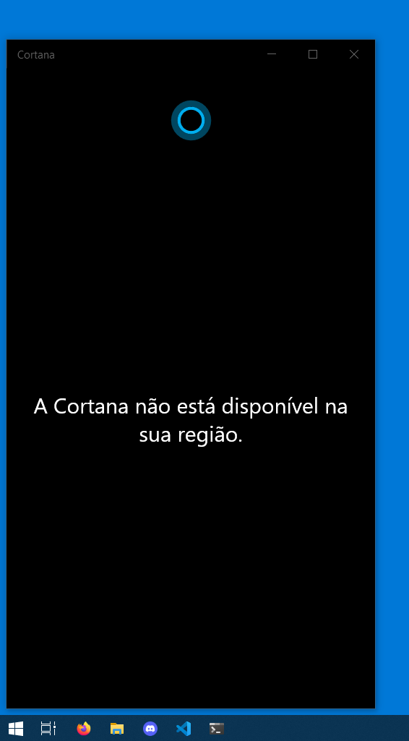

**Flexibility and efficiency of use forcing recognition rather than recall**

**Shortcuts — hidden from novice users — may speed up the interaction for the expert user so that the design can cater to both inexperienced and experienced users. Allow users to tailor frequent actions.**

Windows’ search bar currently suffers from very bad file indexing and so it can hinder the workflow of users who rely on the search function to quickly find what they need. Let’s take one of our own systems as example:

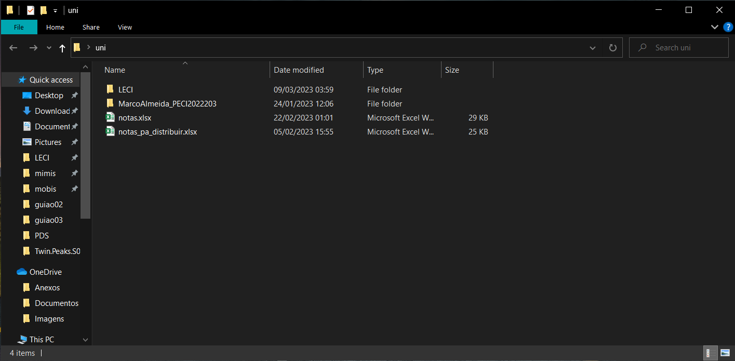

Inside the uni folder there’s another folder named LECI.

If the Windows search bar works correctly, then it should be able to take me to this folder only by typing its name and hitting enter.

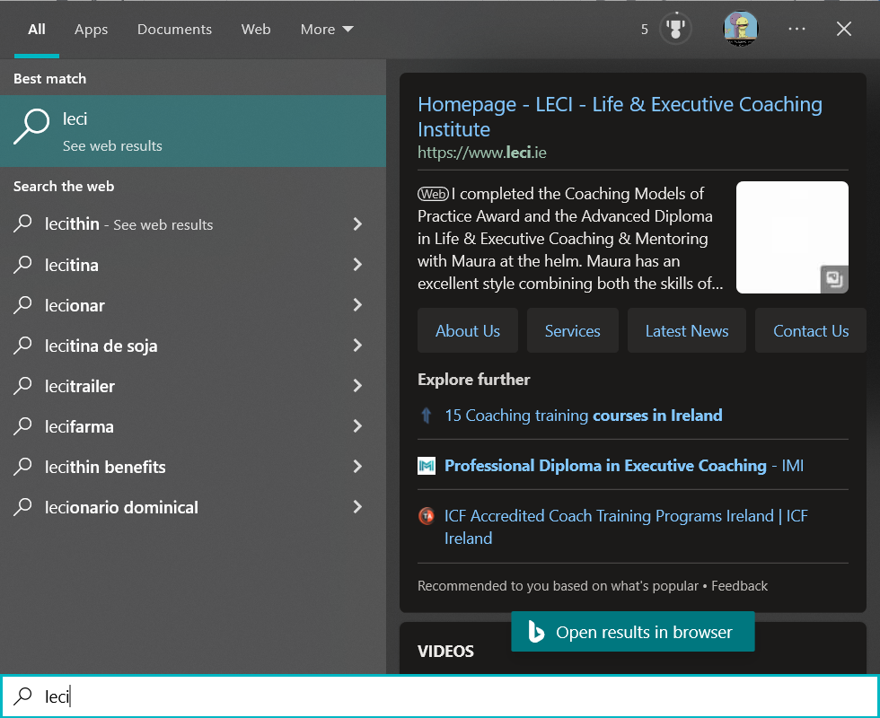

Unfortunately, the folder does not show up as a possible result. This type of error happens in a lot of situations.

Users may be forced to remember specific file locations or program names to find what they need, and if so, this also falls into the recognition rather than recall type heuristic. Another example is the process of changing file permissions for a user, which should be something relatively straightforward but has a lot of steps into it. We will further demonstrate it in the cognitive walkthrough.

**User control and freedom**

**Users often perform actions by mistake. They need a clearly marked "emergency exit" to leave the unwanted action without having to go through an extended process.**

In some cases, Windows 10 may force automatic updates on users without giving them the option to delay or opt-out of the update. This can be frustrating for users who need to use their computer for work or other important tasks.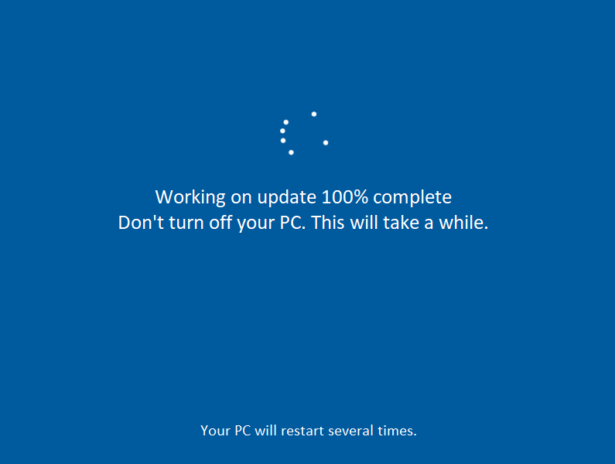

When installing Windows 10, a lot of users would like to create a local account. This means that they don’t want to use or create a Microsoft account, and don’t want to use synchronization features. Depending on which version of Windows 10 is being installed, this may not be straight-forward, as it would require disconnecting the computer from the internet (or not connecting it at all in the first place). This information is not displayed anywhere in the interface.

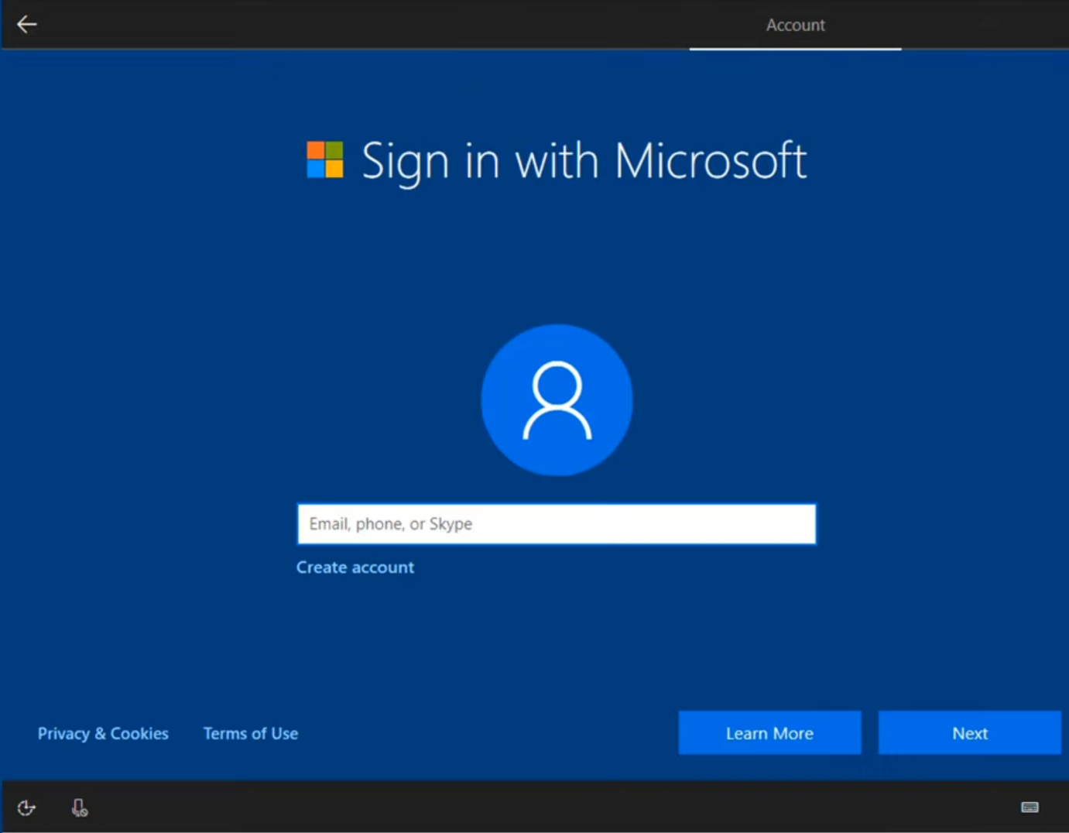

**Aesthetic and minimal design**

**Interfaces should not contain information that is irrelevant or rarely needed. Every extra unit of information in an interface competes with the relevant units of information and diminishes their relative visibility.**

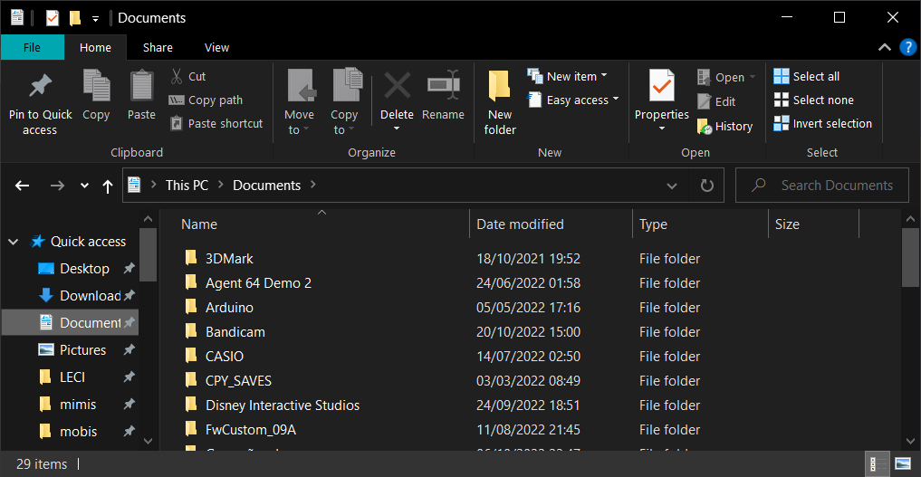

By default, Windows’ file explorer has the home button enabled which displays a lot of buttons which a user may not need to have available often. This is a feature which can be disabled

**Positive point**

**Help and Documentation**

**It’s best if the system doesn’t need any additional explanation. However, it may be necessary to provide documentation to help users understand how to complete their tasks.**

For every single settings page, there is a hyperlink that provides offline help.

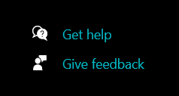

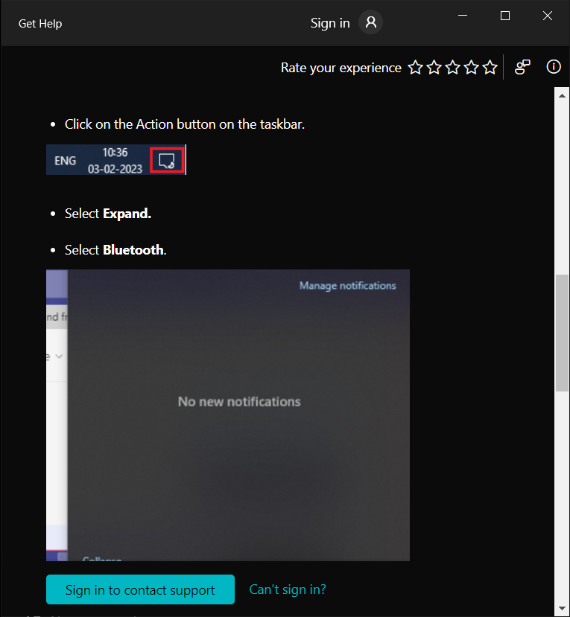

**Match between real system and the real world**

**The design should speak the users' language. Use words, phrases, and concepts familiar to the user, rather than internal jargon. Follow real-world conventions, making information appear in a natural and logical order.**

Windows does a great job at fulfilling this heuristic, hence it’s the most used OS in the world. Linux on the other hand…

**Error prevention**

**Good error messages are important, but the best designs carefully prevent problems from occurring in the first place. Either eliminate error-prone conditions, or check for them and present users with a confirmation option before they commit to the action.**

As an operating system, Windows must ensure that this is done correctly, no user must lose any file whatsoever, for example.

**Severity table**

| Heuristica | Problemas | A | D | M | Mediana |
| --- | --- | --- | --- | --- | --- |
| Consistency and Standards | The system and its native programs use different UI styles | 3 | 3 | 2 | 3 |
| The Settings and the Control Panel are sometimes redundant, but not always, which is confusing | 2 | 4 | 2 | 2 |
| Microsoft Store apps and standalone programs are not always interchangeable | 0 | 2 | 2 | 2 |
| Help users recognize, diagnose, and recover from errors | Error codes being used as diagnostic and so, the typical user cannot possibly know what it means | 4 | 3 | 3 | 3 |
| Visibility of system status | Progress bar/percentage may appear stuck | 2 | 2 | 2 | 2 |
| It’s not trivial to know if Cortana is open or not | 1 | 2 | 2 | 2 |
| User Control and Freedom | Automatic Windows Updates | 2 | 4 | 3 | 3 |
| Forced to create or use Microsoft account when creating Windows | 1 | 4 | 4 | 4 |
| Flexibility and efficiency of use | Poor indexing in search bar | 2 | 2 | 3 | 2 |
| Aesthetic and minimal design | File explorer cluttered with a lot of buttons by default | 1 | 3 | 2 | 2 |

0 = I don't agree that this is a usability problem at all 1 = Cosmetic problem 2 = Minor usability problem 3 = Major usability problem 4 = Usability catastrophe

**Cognitive walkthrough**

**Task:**

Change the default browser defined by the system.

**Users:**

Any windows 10 user who is not happy with the default app for the browser.

**Actions:**

1. click on "home menu"
2. Click "windows search bar",
3. Search for "settings",
4. Go to settings"
5. Enter the "Applications" section
6. Click "Default Applications"
7. Under “Web Browser”, click on the “Edge” or configured browser and switch to the other one.

**Action 1 -** click on "home menu"



Q1 → Yes

Q2 → Yes

**Action 2 -** Click "windows search bar"

Q1 → Yes

Q2 → Yes

**Action 3 -** Either start searching for settings by typing or click the gear button on the left that opens the settings

Q1 → Yes

Q2 → Maybe

Issue → The user might not know that he can search by typing

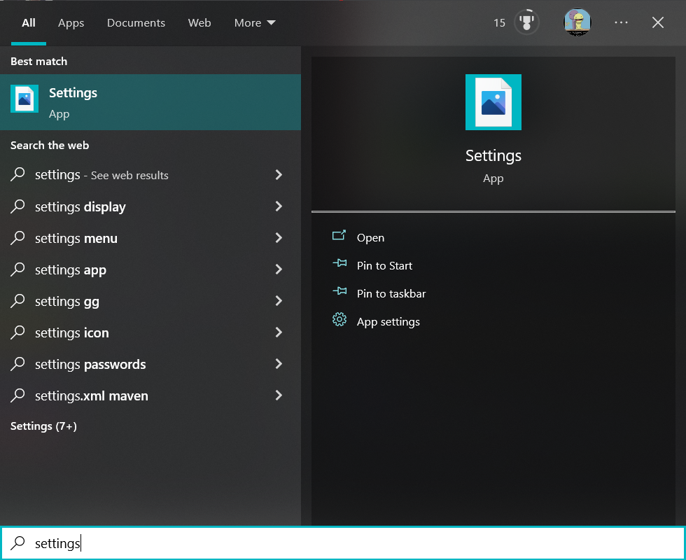

**Action 4 -** Go to “Settings”

Q1 → Yes

Q2 → Yes

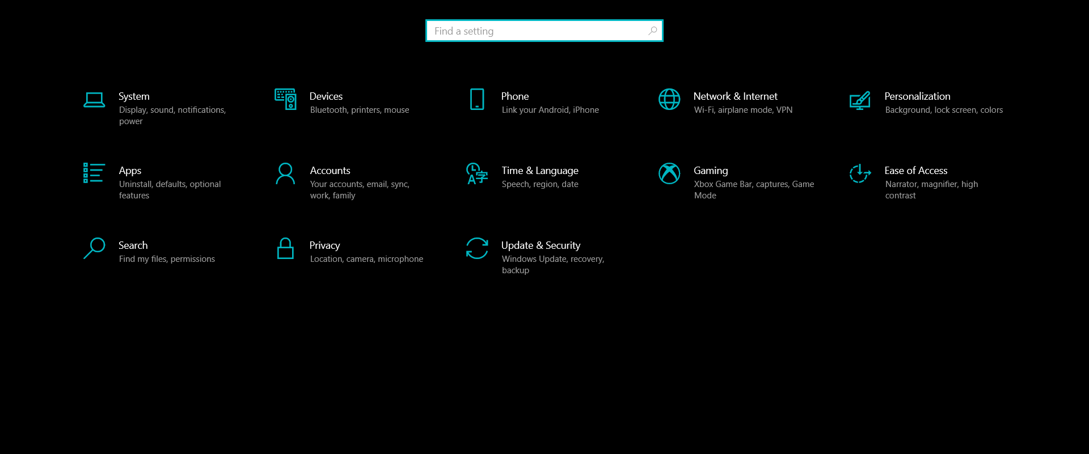

**Action 5 -** Enter the "Applications" section

Q1 → Yes

Q2 → Yes

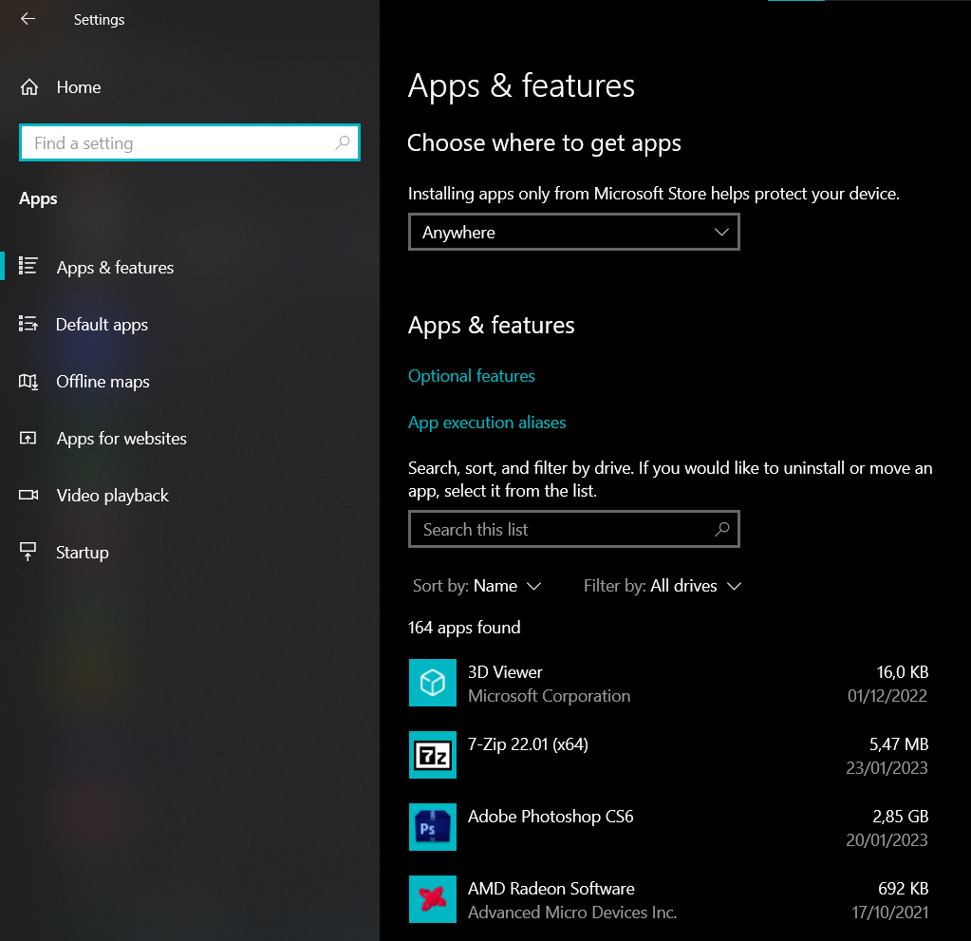

**Action 6 -** Click "Default Applications"

Q1 → Yes

Q2 → Yes

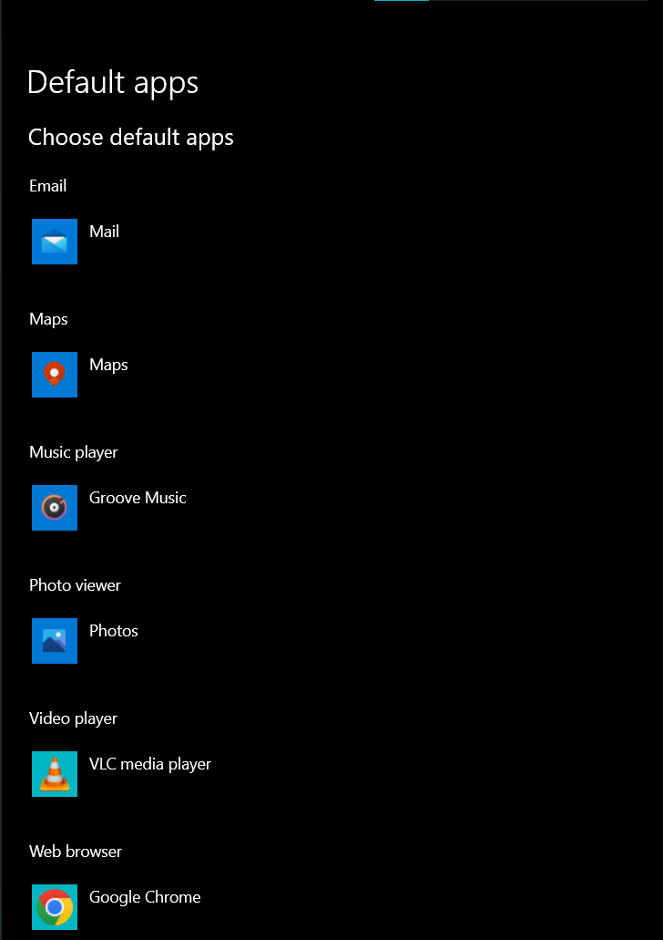

**Action 7 -** Under “Web Browser”, click on the “Edge” or configured browser and switch to the other one.

Q1 → Maybe

Q2 → Yes

